**Project 3 Proposal:**

**Group 1 Team Members:**

* Barsha Basel
* Hiew N Doan (Vincent)
* Micah Raquena-Pequeno
* Richard Thornton
* Roberto Sammassimo

**Topic:**

● A brief articulation of your chosen topic and rationale.

New Zealand is one of the hotspots for earthquake activity in the world. The Geonet site from New Zealand provides local earthquake datasets.

We will be using this data to create a dashboard to visualise New Zealand earthquake activity over the last 365 days including a dynamic summary of data with a map of locality and magnitude.

The purpose of our dashboard will be to explore daily experience of earthquake activity and identify occurrences of severe events in areas of greater risk.

● A link to your dataset(s) and a screenshot of the metadata, if it exists.

[GeoNet: DART Network](https://www.geonet.org/)

[Earthquakes Data NZ | Kaggle](https://www.kaggle.com/datasets/kkhandekar/earthquakes-data-nz)

● Three or four screenshots of relevant, “inspiring” visualisations that show your creative ideas.

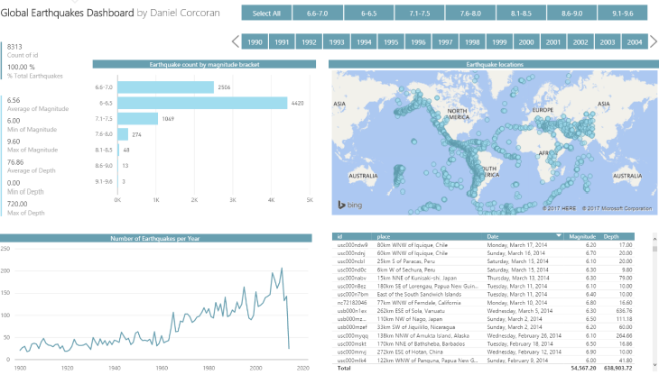

● A sketch of the final design.

● A link to the primary GitHub repository where you’ll be housing your work.  
  
[micah-trp/Project-3-Visualisation-Group-1: Project 3 - Visualisation (github.com)](https://github.com/micah-trp/Project-3-Visualisation-Group-1)

**Resources:**

[New Zealand earthquake causes tiny tsunami - Temblor.net](https://temblor.net/earthquake-insights/new-zealand-earthquake-causes-tiny-tsunami-1300/)

[GeoNet: DART Network](https://www.geonet.org/)

●[POWER BI – GLOBAL EARTHQUAKES (1900-2014) DASHBOARD – Daniels Coding Blog (wordpress.com)](https://danielcorcoranssql.wordpress.com/2017/04/07/power-bi-global-earthquakes-1900-2014-dashboard/)